L/OP8. Join in discussion about stories. Names characters & places in stories. Talks about events and language.1A. Talks about important part of a story, retelling main event. 2B. Discuss an incident and its effects in a story.
Captain Whiskers and the
Fishy Tail
Who? | When?
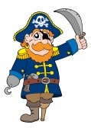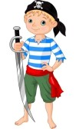  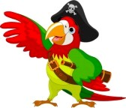 | 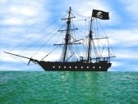
Where? | What?
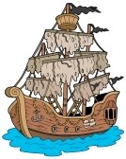 | 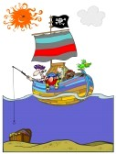
Conclusion?
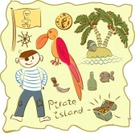

L/OP8. Join in discussion about stories. Names characters & places in stories. Talks about events and language.1A. Talks about important part of a story, retelling main event. 2B. Discuss an incident and its effects in a story.
Captain Whiskers and the
Fishy Tail
Who? | When?
Fidget – cabin boy.  Dastardly Des – quartermaster of the ship  Captain Whiskers - cat.  Pablo Pesos – parrot.  Mermaid. | Long ago when tall ships sailed the seas.
Where? | What?
On board the  Slinky Susan. | Fidget, was treated unkindly by Dastardly Des and the other pirates. He wanted to leave the ship but was trapped. Captain Whiskers and Pablo Pesos were his friends. One day they caught a Mermaid.
Conclusion?
The Mermaid had magical powers and in return for letting her freedom, she helped Fidget, Captain Whiskers and Pablo Pesos esape the evil clutches of Dastardly Des.
L/O: P8 Comments on and joins in discussion of a story. Name a character in a story. 1C Answers questions about what has been read. Names several characters in a story.1B Retell parts of the story. Locate and read key characters names. 2A Can relate to a characters dilemma. State preferences and reasons.
Captain Whiskers and the Fishy Tail
Anna Wilson tells the story of a young boy who mistakenly thought that the life of a pirate would be full of adventure. Let’s read it together and discover what his life was really like.

- Anna Wilson describes how the young boy felt in the opening sentence of her story – what did she write?
pP120

- Every morning Des would beat Fidget, shout at him and then beat him again – what did he shout?
p122

- Anna Wilson uses 5 brilliant adjectives to describe the pirates [p122]. Can you find them?
... bunch of louts.
- She also describes Captain Whiskers as; ‘a suave, debonair sort of chap’ [p123]. Can you draw him?
Captain Whiskers

- We do not know for certain that Captain Whiskers is a cat until p127. However we do start to guess when he licks a ‘rude’ part of his body. Can name it?

pP127

- Did you like this Pirate story? What parts did you like best and least? Talk about it with your friends in your group. Colour in the stars to show how much you liked it.

- Look at the set of mixed-up pictures below – cut them out and rearrange them into the correct story line.
The three friends caught a Mermaid. | The Mermaid took the friends to Pablo’s old home. | Dastardly Des wanted to eat the mermaid.
Captain Whiskers and Pablo Pesos were his friends. | Dastardly Des was very cruel to Fidget. | Fidget thought he wanted to live a pirate’s life.
The friends were hungry and tried to catch a fish. | The three friends helped the Mermaid escape. | Fidget joined the crew aboard the Slinky Susan ship.
Captain Whiskers and the Fishy Tail Story Board
1 | 2 | 3
4 | 5 | 6
7 | 8 | 9

